Financial literacy of young people in Latvia: compulsory on paper, missing in practice
Final research report. Impact case for “Impact Making for the Competitiveness and Data-Driven Decisions”. November 2026.
All Latvia figures in this version are verified against primary documents: - Flash Eurobarometer 525, data annex - Latvijas Banka adult survey 2022 - Latvijas Banka 9th-grade assessment 2025
The few figures still from secondary sources are marked ⚠.

0. Ten insights in one page
- Latvia is joint last in the EU on financial literacy.
  - Only 11% of Latvian adults have a high overall financial literacy score, joint last of 27 with Portugal. The EU average is 18%, Estonia 23% and Lithuania 16%.
  - 24% score low, the 2nd-highest share after Finland (Eurobarometer 525, 2023).
- Latvia’s specific weakness is behaviour and resilience, not only knowledge.
  - Latvia ranks 26th of 27 on financially savvy behaviour (52% high, against an EU average of 65%).
  - It ranks 25th of 27 on setting long-term financial goals.
  - 26% have no emergency savings, the highest share in the EU. Only 19% could live for 6+ months without income, the lowest in the EU.
- Knowledge has collapsed, and the headline index hides it.
  - Latvijas Banka’s index fell only from 63% to 61% between 2015 and 2022.
  - But the knowledge sub-index fell from 5.1 to 3.9 out of 7.
  - Correct answers fell on every question: compound interest 48% → 26%, simple interest 72% → 58%, an interest-free loan 89% → 76%.
  - The fall was masked by better attitudes (2.0 → 2.9 out of 4).
- Young adults are the weakest group.
  - 18–19-year-olds score 8.0 out of 20 and 20–29-year-olds 11.0, against 12.2 overall.
  - Only 40% of 18–19-year-olds can calculate simple interest, against 58% of all adults.
  - The same pattern holds EU-wide: 18–24-year-olds have the lowest share with a high score (13%) and the highest share with a low score (25%).
- School adds little.
  - 9th graders score 61.7% of the maximum, the same as adults (61%).
  - 57% of 9th graders can calculate simple interest, the same as adults (58%).
  - 36% never learn about money at school and 31% rarely; only 9% do so often.
  - 46% learn often from the internet, and 63% from their family.
- Teenagers are already in the market, but don’t understand it.
  - 12% of 9th graders have bought crypto themselves, and 28% have invested with an adult.
  - 31% think Bitcoin is legal tender in Latvia, and only 44% agree that a higher return means higher risk.
  - Among adults, more own crypto (10%) than funds, stocks or bonds (9%). Latvia is joint last in the EU on investment products.
- Teenagers are targets for fraud.
  - 48% of 9th graders have been offered “easy money” online by strangers.
  - 18% have been asked to pass money through their account, the money-mule pattern.
  - 16% have already been scammed buying online, and 6% have given away a password or PIN.
  - Nationally, fraud losses rose from €16m (2024) to €23.7m (2025) ⚠ (State Police). One dismantled network involved 213 money mules from Latvia, mostly young ⚠.
- Teachers are part of the problem. Latvijas Banka found teachers’ knowledge of simple and compound interest insufficient (Brikše 2025).
- Latvia has no international benchmark for students.
  - Latvia scored 501 in PISA 2018, against an OECD average of 505 and Estonia’s world-best 547.
  - It did not take part in PISA 2022’s financial literacy module, and neither did Estonia or Lithuania.
  - Between 2012 and 2018 Latvian students’ scores did not improve (Mihno 2022).
- The evidence on what works is strong.
  - School financial education raises knowledge by 0.15–0.33 SD and behaviour by about 0.07–0.09 SD (Kaiser & Menkhoff 2017, 2020; Kaiser et al. 2022).
  - Large randomised trials: Brazil (+0.25 SD, 892 schools), Peru (credit records improved 3 years later), and an online game (+0.31 SD, 4 countries).
  - Intensity, teacher training and timing (“teachable moments”) decide success.
  - A mandate without real teaching has no effect (Cole et al. 2016). That is Latvia’s risk today.

1. The problem and why it matters

1.1 Latvia in the EU: Flash Eurobarometer 525
Online survey (CAWI), 29 March – 5 April 2023, adults 18+, about 1,000 per country (Latvia n = 1,018), 26,139 in the EU.
Composite scores
Indicator | Latvia | Estonia | Lithuania | EU-27 | Latvia’s rank (of 27)
High overall score (knowledge + behaviour) | 11% | 23% | 16% | 18% | 26th–27th (joint last with PT)
Low overall score | 24% | 16% | 19% | 18% | 2nd highest (after FI 27%)
High knowledge score (4–5 of 5 correct) | 20% | 39% | 25% | 26% | 21st
High behaviour score (all 3 savvy behaviours) | 52% | 54% | 62% | 65% | 26th (only FI lower)
Knowledge questions (% correct)
Question | Latvia | Estonia | Lithuania | EU-27 | Latvia’s rank
Compound interest (€100 at 2% for 5 years: “more than €110”) | 40% | 49% | 38% | 45% | 19th
Inflation (2% inflation: “buy less”) | 69% | 84% | 79% | 65% | 11th
Bonds (interest rates rise: “bond prices fall”) | 14% | 22% | 18% | 20% | 24th
Risk and return (“higher return = more risky”) | 61% | 71% | 58% | 66% | 20th
Diversification (“many shares = less risky”) | 56% | 74% | 63% | 56% | 15th
Behaviour, resilience and products
Indicator | Latvia | Estonia | Lithuania | EU-27 | Latvia’s rank
Completely agree “I set long-term financial goals” | 13% | 12% | 16% | 21% | 25th
Completely agree “I track my expenses” | 38% | 31% | 38% | 49% | 23rd
No emergency savings if income lost | 26% | 15% | 17% | 16% | 1st: highest in the EU
Could cover 6+ months without income | 19% | 32% | 36% | 33% | 27th: lowest in the EU
Own an investment product (funds, stocks, bonds), now or in the past 2 years | 9% | 24% | 14% | 24% | Joint last with BG
Own crypto-assets | 10% | 12% | 11% | 6% | 9th highest
Own none of the seven products | 28% | 18% | 20% | 21% | 4th highest
Private pension product | 23% | 31% | 24% | 22% | 12th
“Very confident” of a comfortable retirement | 5% | 5% | 4% | 9% | 21st
“Somewhat confident” that investment advice is in their interest | 20% | 27% | 30% | 32% | 25th
Self-rated knowledge “very high” | 2% | 5% | 4% | 5% | Joint last
Reading: - Latvia’s problem is concentrated in behaviour (planning, goals, buffers) and investment participation. - On knowledge, Latvia is below average but not last. It even beats the EU average on inflation. - Estonia is the clear regional benchmark: 23% high overall, 39% high knowledge and 24% with investment products.
Youth (EU-level breakdown): - 18–24-year-olds have the lowest share with a high overall score (13% against 18%) and the highest share with a low score (25%). - They also have the highest share with a low behaviour score (16%). - The country tables are not broken down by age, so these are EU figures.
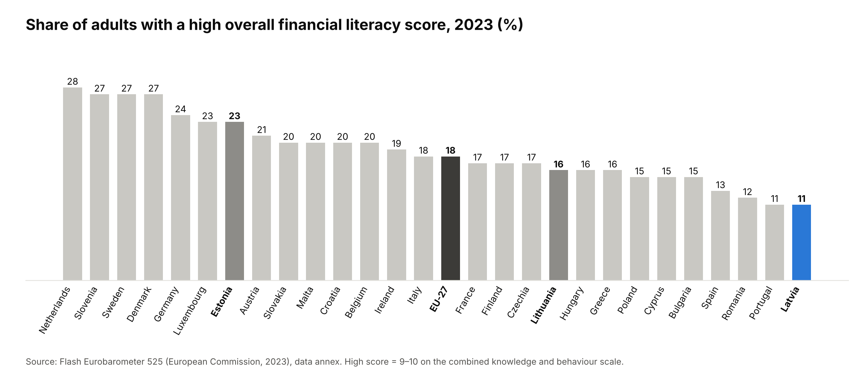
Figure 1. Share of adults with a high overall financial literacy score, EU-27, 2023
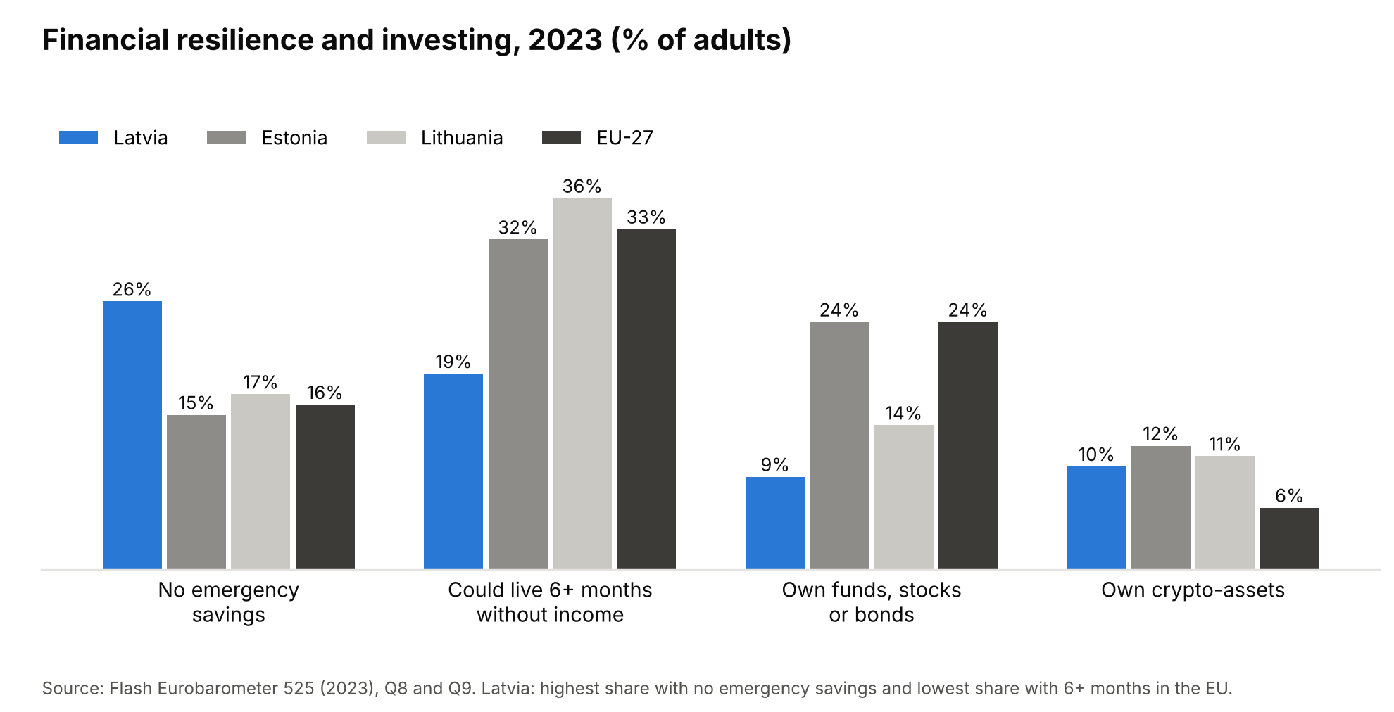
Figure 2. Financial resilience and investing, Baltics vs EU, 2023

1.2 Latvian adults: Latvijas Banka survey 2022
Face-to-face CAPI interviews, 4 Oct – 3 Nov 2022, n = 1,007, ages 18–79, representative random stratified sample, OECD/INFE 2022 toolkit.
The index and its components
Component | 2015 | 2022 | Change
Overall index (% of maximum) | 63% | 61% | −2 pp. OECD average (2020 survey): 62%
Knowledge (0–7) | 5.1 | 3.9 | −1.2 (−24%)
Behaviour (0–9) | 5.3 | 5.4 | flat
Attitudes (0–4) | 2.0 | 2.9 | +0.9
Self-rated knowledge (1–5) | 3.2 | 2.6 | falling (2019: 3.0)
Knowledge questions (% correct), 2015 → 2019 → 2022
Question | 2015 | 2019 | 2022
Divide €1,000 among 5 people | 93% | 92% | 85%
Interest on an interest-free loan (0%) | 89% | 93% | 76%
Simple interest (€100 at 2% after 1 year = €102) | 72% | 74% | 58%
Compound interest after 5 years (> €110) | 48% | 46% | 26%
Inflation: “can buy less” | 68% | 59% | 41%
Caution: in 2022 the inflation question used 21% inflation, reflecting the moment, while earlier years used a different rate. Even the simple division question fell, so part of the drop may reflect fieldwork conditions. But every item fell in the same direction.
Index by group (out of 20)
Group | Index
Age 18–19 | 8.0 (knowledge 3.0, behaviour 2.9, attitudes 2.1) ⚠ small subgroup: about 3% of the sample, roughly 30 people, so indicative
Age 20–29 | 11.0 (knowledge 3.7, behaviour 4.9)
Age 30–39 / 40–49 | 12.6 / 13.1 (peak)
Age 50–59 / 60–69 / 70–79 | 11.9 / 12.7 / 11.9
Education: higher / secondary / basic | 13.4 / 12.1 / 9.2
Income per family member: ≤ €350 vs ≥ €1,001 | 11.2 vs 14.0
Region: Riga lowest (11.6; knowledge only 3.4); Latgale highest (13.8) | —
Gender; Latvian vs Russian home language | No difference (12.2 / 12.1; 12.2 / 12.2)
Simple interest correct, by age: 18–19: 40%; 20–29: 56%; 40–49: 64%; overall 58%.
Resilience and behaviour
Indicator | 18–19 | All adults
Could cover an expense equal to one month’s income without borrowing | 11% | 43% (2015: 29%; 2019: 37%)
Saved in a savings or current account in the past 12 months | 8% | 37%
Saved in cash in the past 12 months | — | 34%
Contributed to the 3rd pension pillar in the past 12 months | — | 17%
Have financial goals | — | 39% (2019: 47%)
No pension plan | — | 30%
Budgeting (all adults): only about 36–37% make an income and expense plan, write down spending, or set aside money for bills.
Investing (all adults, products currently used): - shares 1%, investment account 1%, bonds 0.3%, crypto 2%; - only about 50–57% have even heard of shares, bonds or investment accounts.
Choosing products: - 24–25% of those who chose a current account, a 2nd-pillar fund or a quick loan considered no alternatives; - 34% relied on friends or family, and 9% on unknown people or influencers.
Digital financial literacy: 4.6/10 (knowledge only 1.0/3). Among 18–19-year-olds, only 18% pay bills online.
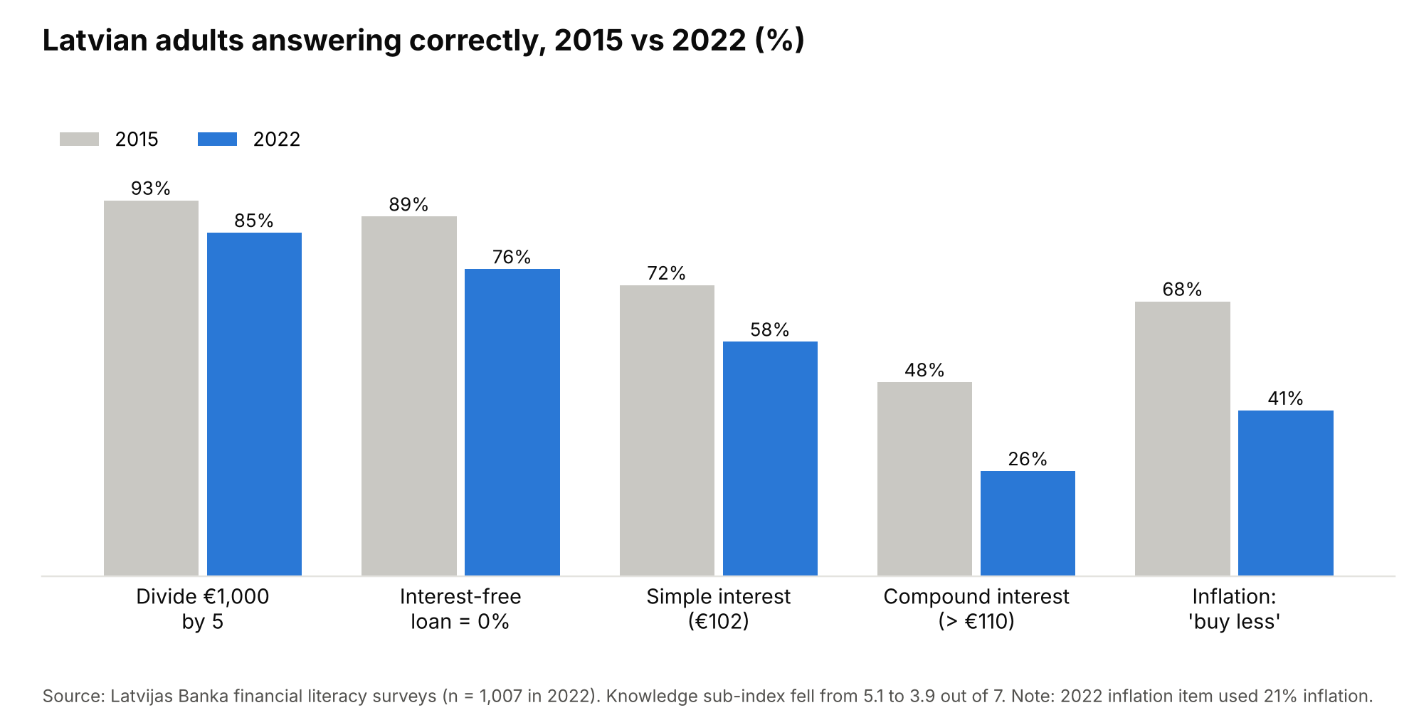
Figure 3. Latvian adults answering knowledge questions correctly, 2015 vs 2022
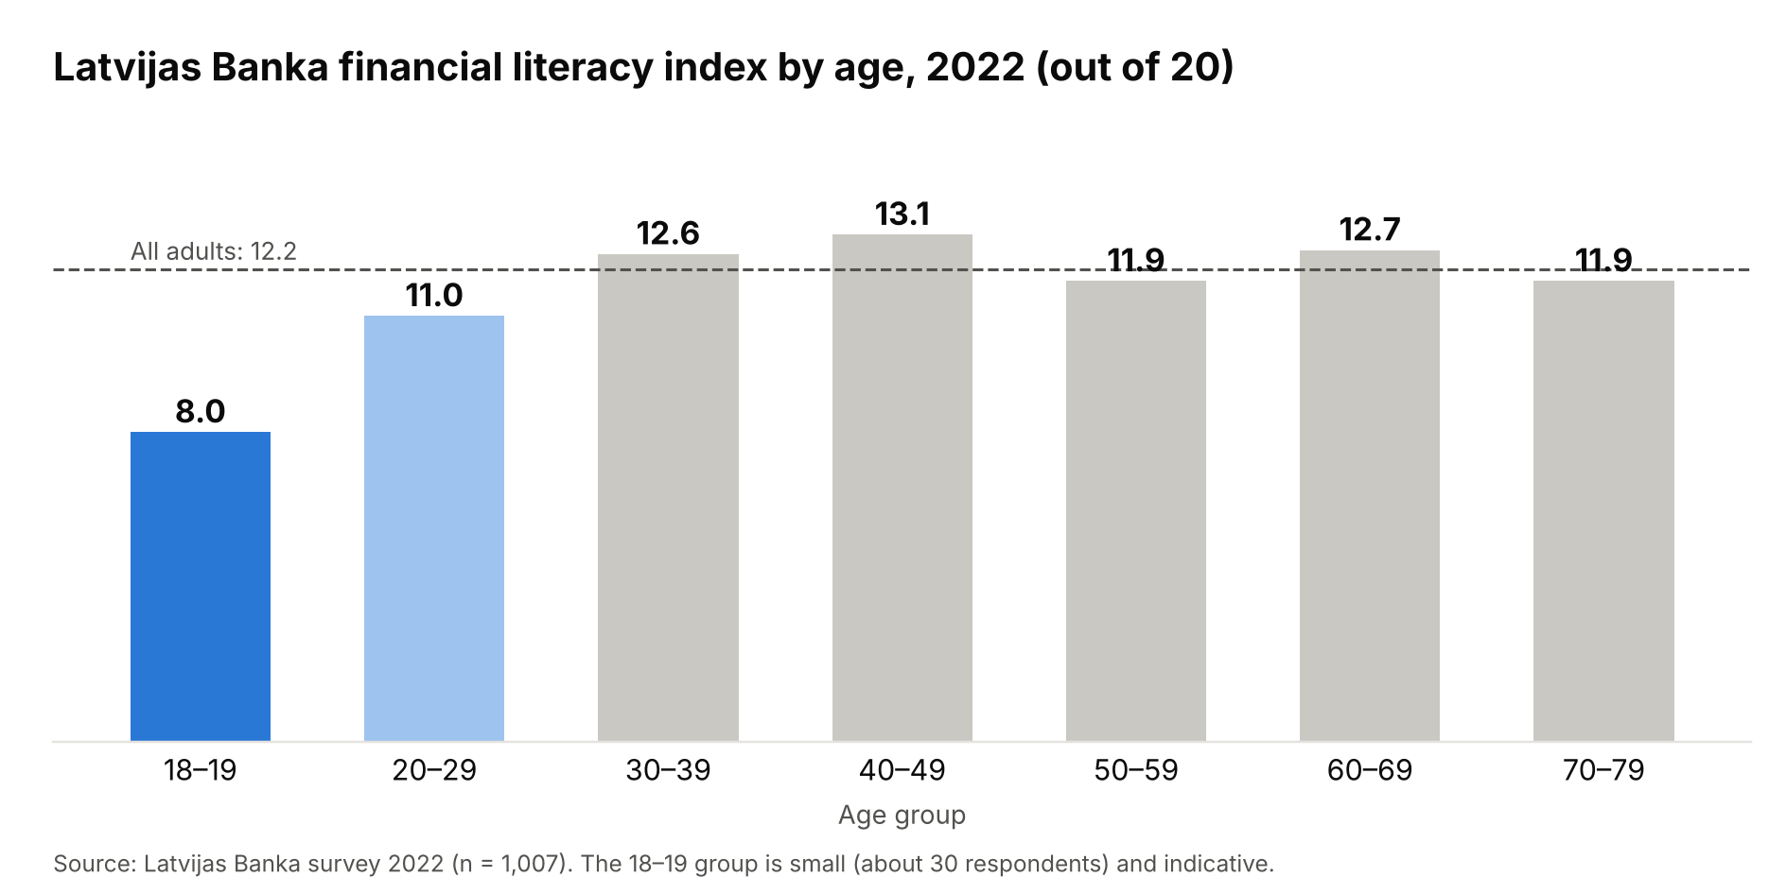
Figure 4. Financial literacy index by age, 2022

1.3 9th graders: Latvijas Banka assessment 2025
Online (CAWI), 10 Feb – 30 Apr 2025, n = 1,159 pupils in 75 schools, carried out by RAIT.
Index - 12.33 / 20 (61.7%), the same level as adults. - Distribution: low 2%, medium 61%, high 37%. - Sub-indices: knowledge 5.46/8 (51% high), behaviour and skills 4.62/8 (only 29% high), attitudes 2.26/4.
Knowledge tasks (% correct)
Task | 9th graders | Adults 2022
Divide €1,000 by 5 | 90% | 85%
Interest-free loan = 0% | 74% | 76%
2nd pension pillar: 5% of a €1,000 salary = €50 | 61% | —
Inflation (2%): “buy less” | 58% | 41% (at 21%)
Simple interest: €100 at 2% = €102 | 57% | 58%
VAT included in €121 at 21% = €21 | 41% | —
Agree “higher return → higher risk” | 44% | —
Misconceptions - 31% think Bitcoin is legal tender in Latvia. - 43% think car insurance is voluntary. - 25% think a budget is balanced when spending exceeds income. - 48% don’t know they join the 2nd pension pillar automatically when they start work. - 40% don’t know how much VAT they pay.
Products and behaviour - 87% have money they control; 85% have their own bank card; 80% have a bank account; 87% have shopped online. - 12% have bought crypto themselves; 28% have invested together with an adult. - 80% save from pocket money (29% regularly); 62% have a savings goal. - 55% sometimes buy things they don’t need; 28% prefer spending to saving. - 24% follow influencers’ recommendations at least sometimes.
Online risk and fraud - 48% offered money-making schemes by strangers on social media. - 18% asked to pass money through their bank account or handle cash for a fee, the money-mule pattern. - 16% scammed when buying online. - 11% opened attachments from strangers, and 6% revealed a password, card number or PIN. - Only 15% regularly change passwords, and 23% think public Wi-Fi is safe for shopping.
Where they learn about money (always or often)
Source | Always or often | Never
Family | 63% | 3%
Internet | 46% | 8%
Friends | 18% | 18%
School and clubs | 9% | 36% (plus 31% rarely)
Family - 73% say only adults make money decisions at home (21% together; 5% don’t know). - 65% say money is discussed freely at home, but only 49% plan a family budget. - (LSM reports, from the full report, that girls score lower than boys and that Vidzeme and Kurzeme pupils score lower.)
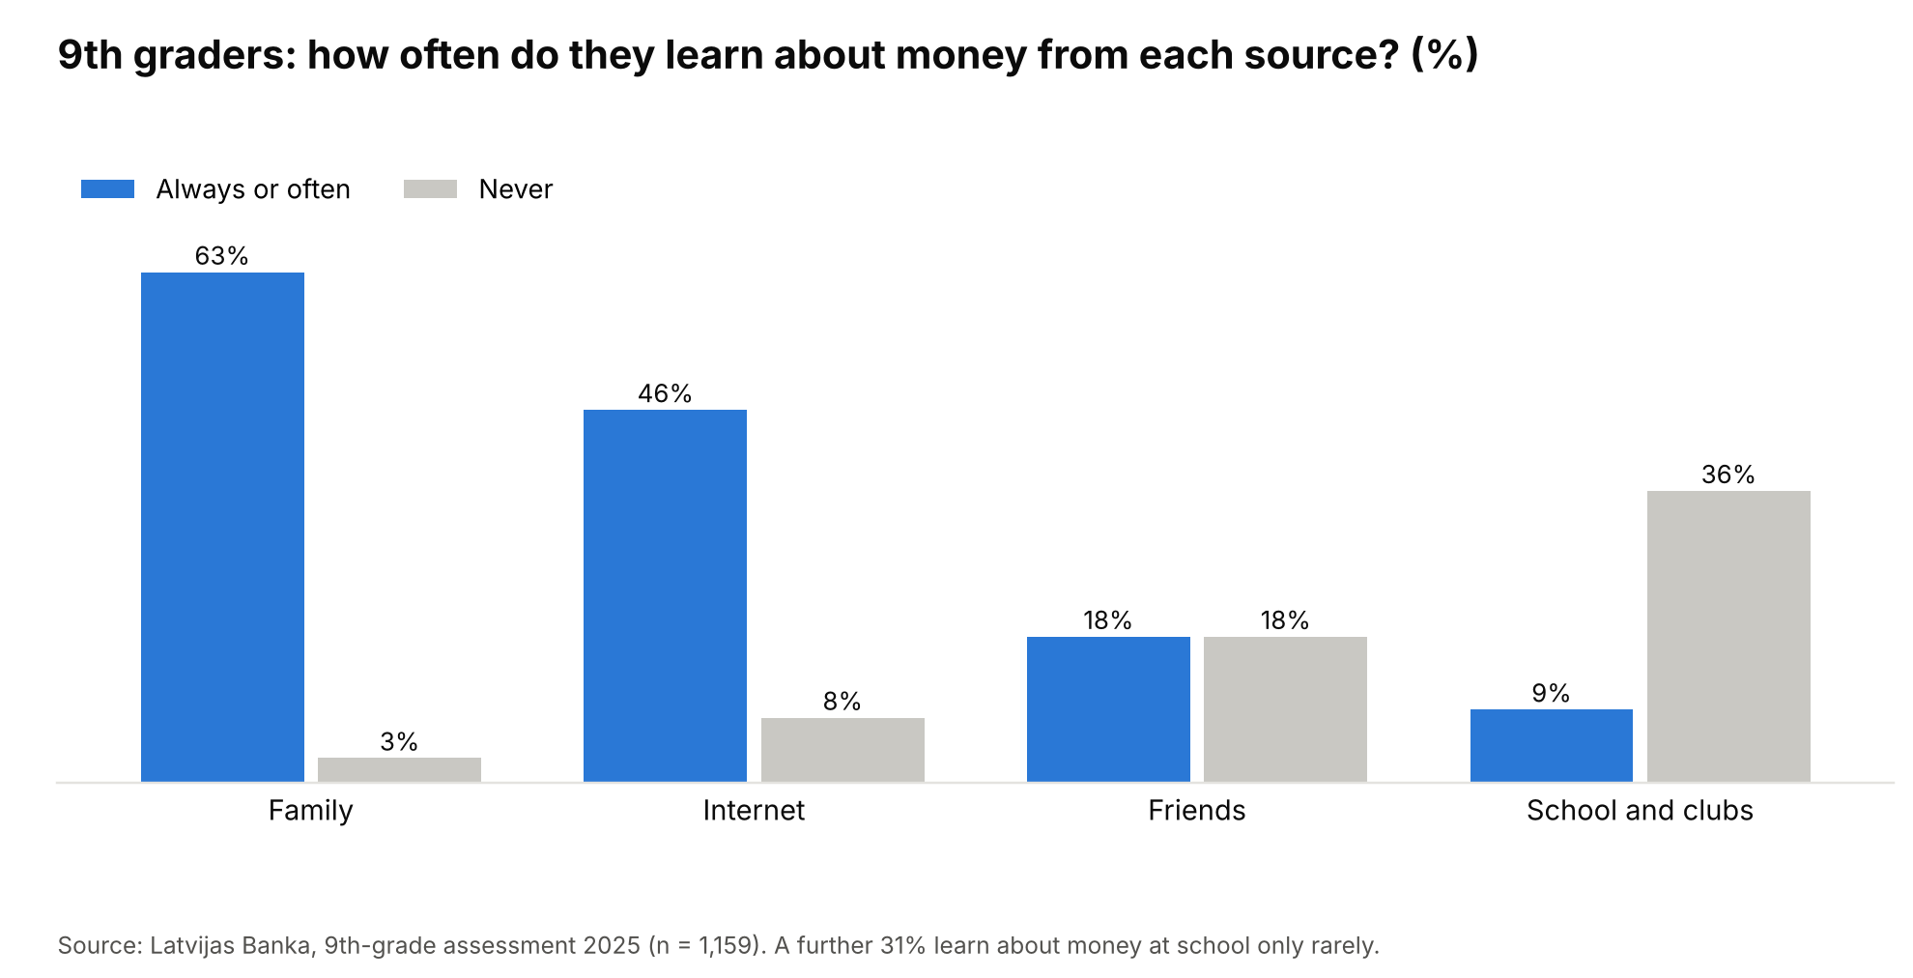
Figure 5. Where 9th graders learn about money, 2025
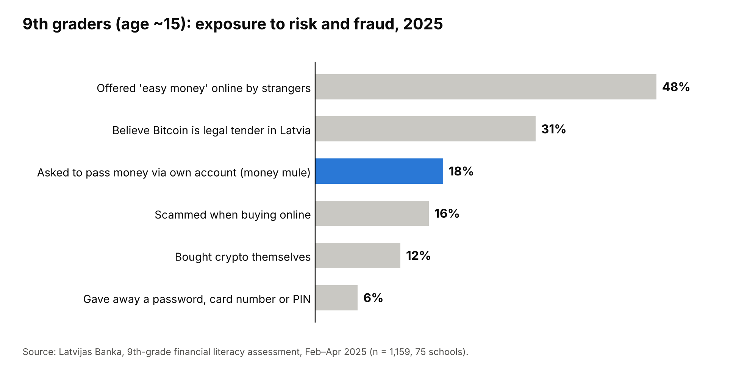
Figure 6. 9th graders’ exposure to risk and fraud, 2025

1.4 The school system
- Status: financial literacy is compulsory, as a topic within social studies from grade 1 and in the upper-secondary social and civic courses (Skola2030). Before the reform it was an elective.
- Quality:
  - teaching is “superficial”, because finance is one topic among many and teachers must cover many fields (LSM, 18.02.2026);
  - teachers’ knowledge of simple and compound interest is insufficient (Latvijas Banka teacher assessment, presented by Brikše in 2025);
  - funding for learning materials is under pressure in the multi-year budget (LSM, 02.06.2026).
- Benchmarking:
  - PISA 2018 financial literacy: Latvia 501, OECD average 505, Estonia 547 (best).
  - Latvia did not take part in PISA 2022’s financial literacy module, which had 20 participants and no Baltic state.
  - PISA 2012 → 2018 showed no improvement (Mihno 2022).
  - Results depend strongly on maths and reading skills, and on socioeconomic background (Mihno 2021).
  - Latvian students struggle most with tasks that require justifying a decision (Kiseļova & Mihno 2018).
- Strategy:
  - National Strategy 2021–2027, coordinated by Latvijas Banka.
  - The strategy itself says the 2014–2020 indicators lacked clear principles and targets.
  - Two strategies later, knowledge is lower than in 2015.

1.5 Why it matters (the stakes)
- Household resilience and pensions.
  - Latvia has the EU’s highest share with no emergency savings, and the lowest share able to last 6 months without income.
  - Low literacy is linked to lower wealth, less stock market participation and worse retirement planning (Lusardi & Mitchell 2014, 2023; van Rooij, Lusardi & Alessie 2011; Lusardi, Michaud & Mitchell 2017).
- Fraud.
  - Teenagers are recruited as money mules; an 18% exposure rate among 15-year-olds.
  - National fraud losses are rising (€23.7m in 2025 ⚠).
- Capital markets. The EU’s Savings and Investments Union and its Financial Literacy Strategy (COM(2025) 681, 30 Sept 2025) aim to turn savers into investors. Latvia starts from joint-last investment participation.
- Timing.
  - Latvia’s national strategy ends in 2027.
  - The EU mid-term review of the Savings and Investments Union is in 2027.
  - The budget for learning materials is being decided now.

2. What does research say?

2.1 Causes (diagnosis)
Cause | Latvian evidence | International evidence
Low intensity: finance diluted within social studies | 36% never learn about money at school; only 9% often | Effects grow with intensity, with diminishing returns (Kaiser & Menkhoff 2017, 2020)
Teacher knowledge | Teachers’ interest knowledge insufficient | Teacher professional development is key but under-studied (Compen, De Witte & Schelfhout 2019)
Weak link to real decisions | Teens already hold cards, crypto and online accounts, but learn from the internet and influencers | “Teachable moments”: education tied to an immediate decision works best (Kaiser & Menkhoff 2017; Fernandes et al. 2014)
Family socialisation | 73% of 9th graders are not involved in money decisions; involvement predicts higher scores | Family and school are complementary channels (Grohmann, Kouwenberg & Menkhoff 2015)
Inequality | Basic education 9.2 vs higher 13.4; low income 11.2 vs high 14.0 | Gaps by socioeconomic status persist (Lusardi, Mitchell & Curto 2010; Mihno 2021)
No measurement loop | No PISA financial literacy since 2018; weak strategy indicators | —

2.2 Solutions and their expected impact
Meta-analyses
Study | Coverage | Knowledge | Behaviour | Key moderators
Fernandes, Lynch & Netemeyer (2014), Management Science | 201 studies | — | 0.1% of variance | Effects decay over time, so just-in-time education is better
Kaiser & Menkhoff (2017), World Bank Economic Review | 126 studies | 0.26 SD | 0.09 SD (0.08 in RCTs) | Intensity and teachable moments matter; weaker for low-income groups; borrowing is harder to change than saving; mandatory programmes possibly weaker
Kaiser & Menkhoff (2020), Economics of Education Review | 37 school experiments | 0.33 SD (RCTs 0.15) | 0.07 SD | Intensity, with diminishing returns
Kaiser, Lusardi, Menkhoff & Urban (2022), Journal of Financial Economics | 76 RCTs, 160,000+ people | Positive | Positive | Comparable to education interventions in other fields; robust to publication bias
Key school trials and natural experiments
Study | Design | Result
Bruhn et al. (2016), AEJ: Applied | RCT, 892 schools, ~25,000 students, Brazil | Proficiency +0.25 SD; more saving and budgeting; spillovers to parents; but more expensive consumer credit
Frisancho (2020), IDB | RCT, 300 schools, Peru | Knowledge +0.15 SD; better credit records 3 years later; poorer parents’ default probability −26%
Cannistrà et al. (2024), Journal of Comparative Economics | RCT, 2,220 students, 4 countries; an online escape-room game | +0.313 SD
Lührmann, Serra-Garcia & Winter (2015), Journal of Banking & Finance | German low-SES schools; 90-minute sessions by volunteer professionals | More interest and knowledge (especially risk); fewer impulse purchases; no change in saving
Urban, Schmeiser, Collins & Brown (2020), Economics of Education Review | US state mandates with dedicated courses; difference-in-differences with credit data | Higher credit scores, lower delinquency, with a lag
Cole, Paulson & Shastry (2016), Journal of Human Resources | Earlier US mandates | No effect of personal finance mandates; maths training helped
Batty, Collins & Odders-White (2015), Journal of Consumer Affairs | US elementary schools | Knowledge and attitudes improved
Design principles from the evidence 1. A dedicated, intensive block of lessons rather than scattered mentions. 2. Trained teachers. 3. Content tied to the real decisions teenagers face now: cards, online shopping, crypto, fraud, first salary and the 2nd pension pillar. 4. Game-based and short, repeated formats. 5. Involving parents. 6. Measure results, and expect knowledge to move before behaviour.
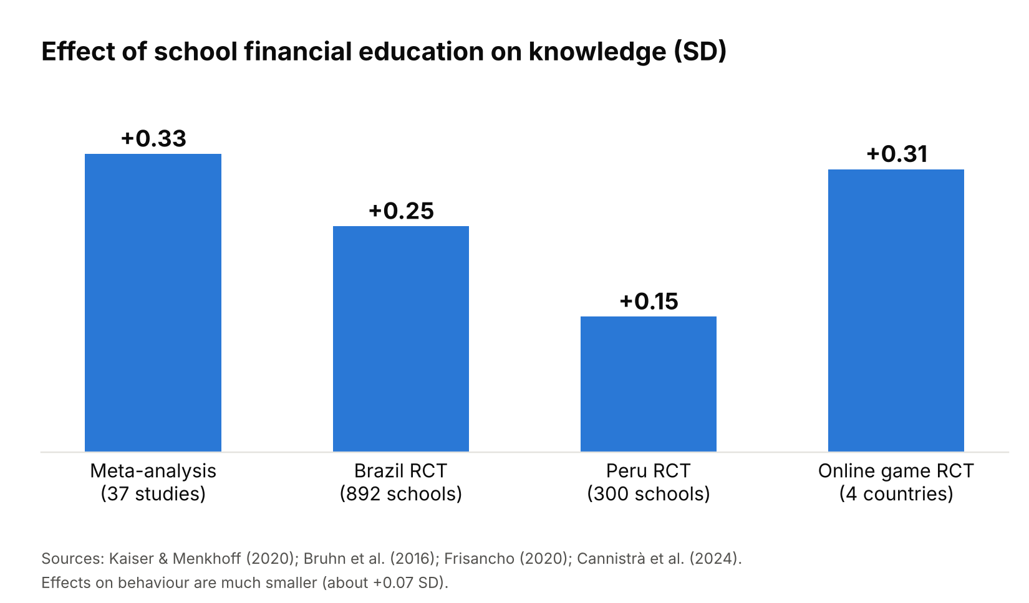
Figure 7. Effects of school financial education on knowledge, key studies

2.3 Expected impact (illustrative)
- Knowledge. Moving 9th graders by +0.15 to +0.30 SD would roughly close a third to half of the gap between Latvia’s 9th-grade knowledge level and the “high” band.
  - It would plausibly bring the simple-interest share from 57% to 65–70%.
  - This is an illustration based on the meta-analytic effect sizes, not a forecast.
- Behaviour. Expect +0.07 to +0.09 SD, visible over years, not months. Credit effects appeared with a lag in the US (Urban et al. 2020) and Peru (Frisancho 2020).
- Fraud. There is no causal estimate for money-mule recruitment. Treat it as a monitored outcome, using the 9th-grade survey question on mule approaches.

3. What should be done
Goal: by 2030, make compulsory financial education real: taught intensively, by trained teachers, linked to real decisions, and measured.
- A ready-to-teach module.
  - 10–12 lessons in grade 9 and again in grade 11, aligned with the EU/OECD competence framework for children and youth.
  - Topics: interest and compounding, inflation, risk and return, cards and online payments, crypto versus legal tender, fraud and money mules, first salary, taxes and the 2nd pension pillar.
  - Owners: IZM and VISC, with Latvijas Banka.
- Teacher professional development.
  - A short certified course for social studies teachers, focused on the weak spots: interest, compounding and risk.
  - Designed on Compen et al. (2019): content focus, active learning, duration, collaboration.
  - Owners: Latvijas Banka, VISC and universities.
- Gamified, repeated activities spread through the year.
  - Classroom games (an escape-room format); an Open Economics Olympiad and Baltic competitions.
  - Volunteer “finance coaches” from banks (Finance Latvia).
  - Partners: Latvijas Banka, banks, and NGOs such as Jaunie Ekonomisti and Junior Achievement.
- Family tasks. Homework that involves parents in a real household money decision, such as a budget or comparing offers. This targets the 73% of pupils who are excluded from these decisions.
- Measurement.
  - Repeat Latvijas Banka’s 9th-grade assessment every 2 years.
  - Report the adult survey’s 18–29 age group with a larger youth sample.
  - Rejoin the PISA financial literacy module in the next cycle that offers it ⚠.
  - Put clear indicators into the post-2027 national strategy.
KPIs (baseline → target, 2030)
KPI | Baseline | Target 2030
9th-grade index | 12.33 (2025) | 14.0
9th graders who calculate simple interest | 57% (2025) | 75%
9th graders who “never” learn about money at school | 36% (2025) | < 10%
9th graders who know Bitcoin is not legal tender | 69% (2025) | 90%
Adult knowledge sub-index | 3.9 / 7 (2022) | Back to 2015 level (5.1)
Ages 20–29 overall index | 11.0 (2022) | ≥ 12.2 (adult average)
Teachers passing the core-concepts check | Baseline from Latvijas Banka assessment | 80%
PISA financial literacy | Not participating | Participating

Part B. Evidence for the solution: newer data, curriculum, existing activity, Estonia, costs and policy window

B1. Is there newer adult data than 2022?
Yes: the OECD/INFE 2023 international survey, with data from 2022–2023 and 39 countries, as reported by Latvijas Banka:
Indicator | Latvia | OECD average
Overall financial literacy (% of maximum) | 59% | 63%
Adults reaching the minimum target score | 46% | 58%
Digital financial literacy | 46% | 55%
Victim of financial fraud in the past 2 years | 18% | — (described as above average)
What this means for the case - The 2023 international result (59%) is lower than Latvijas Banka’s own 2022 figure (61%). So the low level is confirmed by a second, independent survey. - Fewer than half of Latvian adults (46%) reach the OECD’s minimum target, against 58% across the OECD. This is a strong and simple headline. - 18% of adults have been victims of financial fraud in two years, which links directly to the fraud findings among teenagers.
What was not found - No newer Latvijas Banka adult index than 2022. - Latvijas Banka’s 2025 slides mention a 2024 teacher survey and the 2025 9th-grade survey, not a new adult survey. - Latvijas Banka’s own page confirms that “financial knowledge has declined over seven years, weakest among 18–19-year-olds and people with lower education”, while attitudes improved.
Why did knowledge fall? No official explanation was found. Plausible factors: 1. The 2022 inflation question used 21% inflation, so that item isn’t fully comparable. 2. Fieldwork took place during the 2022 energy and inflation shock. 3. A genuine decline. Every item fell, including simple division (93% → 85%), which suggests part of the drop could be a survey effect.
Recommendation: present it as “knowledge has fallen on every question since 2015, and the OECD 2023 survey confirms the low level”. Ask Latvijas Banka for its interpretation, which also makes a good interview question.

B2. Teachers: what we know
- Latvijas Banka 2024 survey of teachers of economics and financial literacy topics (presented by Brikše at the Saeima conference, 12 Sept 2025):
  - “Teachers’ knowledge of simple and compound interest is insufficient. This may affect their ability to teach investment, savings, pensions and borrowing.”
  - Teachers of finance and economics topics also lack sufficient knowledge of basic economic and financial concepts.
  - The school system plays a limited role in improving financial literacy, and teachers’ lack of preparation is listed as a challenge.
- ⚠ The slide appears to compare correct answers on the €100 savings-account question: adults 58%, 9th graders 57%, teachers 38%. The extracted text is jumbled, so this needs the original slide before use. If confirmed, teachers scoring below their own pupils would be one of the case’s most striking facts.
- Action: upload the Saeima slide deck (m.saeima.lv, document e0d28b52…) or Latvijas Banka’s 2024 teacher report, and I will verify it.

B3. What the curriculum actually requires
What we know - Financial literacy is compulsory, but not a separate subject. It is part of social studies (sociālās zinības) from grade 1, and of the upper-secondary social and civic courses (general, optional and advanced levels). - Before Skola2030, “economics and financial literacy” was an elective taken by some pupils only. - Grade 7–9 learning outcomes include explaining how resources are allocated and how the market works, and making responsible decisions by evaluating services offered by financial institutions. - Skola2030 provides a “Financial literacy” assessment criteria sheet for social studies lessons, and textbook units on banks and money. - Quality: LSM (18.02.2026) reports “superficial” teaching because: - finance is one of many social studies topics; - teachers must be experts in many fields; - finance professionals rarely visit.
More materials are planned, but funding for learning materials is under budget pressure (LSM, 02.06.2026).
What was not found: the number of lessons devoted to finance. The standard sets total social studies hours, not hours per topic. This is itself a finding: no minimum number of finance lessons is guaranteed, so delivery depends on each teacher.
Action: one or two short interviews with social studies teachers: “How many lessons per year actually cover money and finance?”

B4. What already exists in Latvia (activity is high, results are flat)
Initiative | Reach
National strategy partners | 22 partners, 115+ activities in 2024; 230+ activities since 2021
Latvijas Banka’s own sessions | ~2,000 people in 2024, rated 4.8/5
“Naudas diena” (Money Day) for schools | 510 schools, 78% of general and vocational schools (2023)
Financial Literacy Week | Annual, nationwide
SEB School Ambassadors | Pupils teach pupils in schools across Latvia (5+ years)
Junior Achievement Latvia | A record ~1,500 student companies (2023)
Latvijas Banka school material “Manu ekonomiku”; adult programme “Kļūsti par naudas pratēju” (with IZM) | —
New cooperation memorandum, 16 March 2026 | 28 organisations. Priorities to 2027: pupils and teachers, investment culture, responsible borrowing, research
Key insight: Latvia is rich in activity but poor in results. - Hundreds of events, and 78% of schools reached on Money Day. - Yet knowledge fell from 2015 to 2022, and 36% of 9th graders say they never learn about money at school. - The strategy counts activities (partners, events, participants), not learning outcomes. - The 2021–2027 strategy itself admits that its earlier indicators lacked clear principles and targets. - This fits the international evidence: one-off events are low-intensity, and intensity is what drives impact (Kaiser & Menkhoff 2017, 2020).
This lets us reframe the solution: Latvia doesn’t need more events. It needs to turn existing activity into intensive, assessed classroom learning delivered by trained teachers.

B5. How Estonia does it (and what to be careful about)
The model - A national strategy “Money Smart Estonia” 2021–2030, led by the Ministry of Finance, with the Ministry of Education and partners including the NGO Rahatarkus. - Teachers. An Estonian 2020 study found many teachers lacked formal training in financial education. In response: - financial literacy has been part of a six-month training programme for entrepreneurship teachers since 2019; - materials and games are shared online for all school stages. - Integration with entrepreneurship education. The Ministry of Education’s “Edu ja Tegu” programme (since 2016) trains teachers and provides methods and materials: - teachers from 58% of education institutions had taken part by 2022; - entrepreneurship education was implemented in 71% of general schools (2021); - financial literacy is embedded in it. - Scale: 506 general schools, ~17,500 teachers, ~164,000 pupils. - Results: PISA 2018 financial literacy 547, the best in the world. Among 18–29-year-olds, 91% save in some form (Estonian Ministry of Finance, 2024).
Caution - Estonia also leads Europe in PISA maths and reading. - Financial literacy scores depend heavily on maths and reading (OECD; Mihno 2021). - Its lead is therefore not only the result of financial education.
What to borrow from Estonia (in our recommendations) - Systematic teacher training, integrated into an existing teacher programme. - Ready-made materials for every school stage. - Linking finance to entrepreneurship education. - A ministry-level owner.
Lithuania, for completeness - A Public Financial Education Action Plan 2024–2028, coordinated by a council chaired by the Ministry of Finance (with the central bank and Junior Achievement). - A pilot of a dedicated financial literacy lesson from grade 1 (about 2,400 children), aiming to embed a lesson in the national curriculum and train teachers. ⚠ Status unclear.

B6. Rough cost of the proposal (illustrative)
Benchmarks from the research - Peru (Frisancho): US$6.6 per student, including workbooks, distribution, teacher training and monitoring. - Brazil (Bruhn et al.): BRL 206 per student. Students’ lower use of expensive credit saves about BRL 46 a year, so the programme pays for itself in about 5 years.
Latvia: assumptions (to be checked with IZM and VISC) - About 640 general schools (643 in 2023, CSP). - About 20,000 pupils per grade cohort, based on ~19,000 births a year in 2010–2011 ⚠. - About 1,000 social studies teachers teaching grades 7–12, roughly 1.5 per school ⚠.
Item | Assumption | Cost
Develop the module (grades 9 and 11), digital, based on existing Latvijas Banka and Skola2030 material | One-off | €50–100k
Teacher training (36-hour certified course) | ~1,000 teachers × €150–250 | €150–250k one-off
Delivery: materials, games, competitions, volunteer coaches | ~20,000 pupils × €5–10 per year | €100–200k a year
Measurement | Latvijas Banka 9th-grade survey every 2 years (already exists) | Within current budgets
Total |  | About €0.2–0.35m set-up + €0.1–0.2m a year
Perspective - National fraud losses were €23.7m in 2025 ⚠ (State Police), and 18% of adults were fraud victims in two years (OECD/INFE). - The programme costs about 1% of one year’s fraud losses a year. - The Brazilian evidence suggests it can pay for itself through lower borrowing costs within about 5 years. - Partners (Latvijas Banka, commercial banks via Finance Latvia, and EU funds such as ESF+) could cover part of it.
These are back-of-envelope figures to show the order of magnitude, not a budget.

B7. The policy window: why now
- The national strategy 2021–2027 ends next year. A 2025 strategy evaluation exists (⚠ “Stratēģijas izvērtējums 2025”, bank.lv, not yet read). The successor strategy must be prepared in 2026–2027, and no public draft was found, so it is still open to influence.
- The 28-organisation memorandum (March 2026) names pupils and teachers as a priority up to 2027. Our proposal fits an agreed priority, with partners already signed up.
- EU Financial Literacy Strategy (COM(2025) 681, 30 Sept 2025) and the Savings and Investments Union mid-term review in 2027. EU-level backing and possible funding.
- Budget pressure on learning materials (2026). A low-cost, high-evidence proposal is easier to fund than a new subject.

B8. Open items before submission
- Latvijas Banka teacher survey 2024, or the Saeima slide deck (m.saeima.lv). Needed to confirm the “teachers 38%” figure.
- Latvijas Banka “Stratēģijas izvērtējums 2025” (bank.lv). The official mid-term evaluation of the strategy, and probably the single most useful remaining document.
- The full 9th-grade report (2025) for the gender and region gaps.
- Optional: the OECD/INFE 2023 report (Latvia country figures).
- Interviews: one at Latvijas Banka (financial literacy unit), one or two social studies teachers, and VISC if possible.

Appendix A. Methodology and frameworks
- Definitions and frameworks:
  - OECD/INFE: financial literacy = knowledge + behaviour + attitudes. This structures both the Latvijas Banka indices and the OECD survey.
  - The EU/OECD financial competence frameworks for children, youth and adults.
  - Lusardi & Mitchell’s human-capital view and their “Big Three” questions.
  - Kaiser & Menkhoff’s intensity and teachable-moment design lens.
  - The family-and-school socialisation model (Grohmann et al. 2015).
- Data:
  - Flash Eurobarometer 525 (online panel, quota sample, about 1,000 per country). Ranks computed from the data annex by the authors.
  - Latvijas Banka 2022 (face-to-face, random stratified, n = 1,007).
  - Latvijas Banka 2025 9th-grade assessment (online, 75 schools, n = 1,159).
  - OECD PISA 2018 and 2022 Volume IV.
- Limitations:
  - The Eurobarometer is an online panel, so it may overstate digital populations.
  - The 18–19 subgroup in the 2022 survey is about 30 respondents (indicative only), but 20–29-year-olds show the same pattern.
  - The 2022 inflation question changed its parameter, so the trends are indicative.
  - The 9th-grade results are a single cross-section (no trend yet).
  - Most causal evidence is from outside the Baltics; Cannistrà et al. (2024) is the closest.
  - Jaunie Ekonomisti’s own Olympiad data is used only as illustration (non-representative).

Appendix B. Evidence register
Claim | Source | Status
Latvia 11% high overall score, joint last | FL525 annex, “Overall financial literacy score” | ✅ verified
26% no emergency savings (highest in EU); 19% 6+ months (lowest) | FL525 Q8 | ✅
9% investment products (joint last); 10% crypto | FL525 Q9 | ✅
Behaviour high 52% (26th of 27); goals 13% (25th) | FL525 behaviour score; Q7_3 | ✅
Index 63% → 61%; knowledge 5.1 → 3.9; attitudes 2.0 → 2.9 | Latvijas Banka 2022 pp. 7–14 | ✅
18–19-year-olds 8.0; 40% simple interest | Latvijas Banka 2022 pp. 8, 53 | ✅ (small n)
9th grade 12.33; school 9% / 36%; scams 48% / 18% / 16%; crypto 12%; Bitcoin 31% | Latvijas Banka 9th grade 2025 | ✅
Teachers’ interest knowledge insufficient | Brikše (Latvijas Banka) 2025 presentation | ✅ (presentation)
Latvia not in PISA 2022 financial literacy | OECD PISA 2022 Volume IV participant list | ✅
Fraud losses €23.7m (2025); 213 money mules | State Police via BB.lv | ⚠ media
Girls and Vidzeme/Kurzeme lower (9th grade) | LSM summary of the full report | ⚠ media

References
- European Commission (2023). Flash Eurobarometer 525: Monitoring the level of financial literacy in the EU. Ipsos, fieldwork 29.3–5.4.2023.
- Latvijas Banka (2022). Latvijas iedzīvotāju finanšu pratības aptauja 2022 (Latvijas Fakti; OECD/INFE 2022 toolkit).
- Latvijas Banka (2025). Latvijas skolu 9. klases skolēnu finanšu pratības novērtējums (RAIT; n = 1,159).
- Brikše, A. (2025). Jaunās paaudzes finanšu pratības veicināšana skolā un ģimenē. Latvijas Banka, Saeima conference.
- OECD (2024). PISA 2022 Results (Volume IV): How Financially Smart Are Students?
- OECD (2020). PISA 2018 Results (Volume IV): Are Students Smart about Money?
- European Commission (2025). Financial Literacy Strategy for the EU, COM(2025) 681.
- Bruhn, M., et al. (2016). AEJ: Applied Economics, 8(4), 256–295.
- Cannistrà, M., et al. (2024). Journal of Comparative Economics, 52(4), 825–847.
- Cole, S., Paulson, A., & Shastry, G. K. (2016). Journal of Human Resources, 51(3), 656–698.
- Compen, B., De Witte, K., & Schelfhout, W. (2019). Educational Research Review, 26, 16–31.
- Fernandes, D., Lynch, J. G., & Netemeyer, R. G. (2014). Management Science, 60(8), 1861–1883.
- Frisancho, V. (2020). The impact of financial education for youth. IDB Working Paper.
- Grohmann, A., Kouwenberg, R., & Menkhoff, L. (2015). Journal of Economic Psychology, 51, 114–133.
- Kaiser, T., & Menkhoff, L. (2017). World Bank Economic Review, 31(3), 611–630.
- Kaiser, T., & Menkhoff, L. (2020). Economics of Education Review, 78, 101930.
- Kaiser, T., Lusardi, A., Menkhoff, L., & Urban, C. (2022). Journal of Financial Economics, 145, 255–272.
- Lührmann, M., Serra-Garcia, M., & Winter, J. (2015). Journal of Banking & Finance, 54, 160–174.
- Lusardi, A., & Mitchell, O. S. (2014). Journal of Economic Literature, 52(1), 5–44.
- Lusardi, A., & Mitchell, O. S. (2023). Journal of Economic Perspectives, 37(4), 137–154.
- Lusardi, A., Michaud, P.-C., & Mitchell, O. S. (2017). Journal of Political Economy, 125(2), 431–477.
- Mihno, J. (2021, 2022); Kiseļova, R., & Mihno, J. (2018). Latvian PISA financial literacy analyses.
- Urban, C., Schmeiser, M., Collins, J. M., & Brown, A. (2020). Economics of Education Review, 78, 101786.
- van Rooij, M., Lusardi, A., & Alessie, R. (2011). Journal of Financial Economics, 101(2), 449–472.
- BB.lv (2025, 2026). State Police reports on fraud losses and money-mule networks. https://en.bb.lv/article/emergencies-and-crime/2025/12/29/criminal-network-uncovered-involving-over-200-money-mules-from-latvia-82560

Additional sources (Part B)
- Latvijas Banka. “Latvijā finanšu pratībā izaicinājumu netrūkst” (OECD/INFE 2023 results). https://www.bank.lv/aktualitates-banklv/zinas-un-raksti/jaunumi/16730-latvija-finansu-pratiba-izaicinajumu-netrukst ; LSM (18.12.2023). https://www.lsm.lv/raksts/zinas/ekonomika/18.12.2023-latvijas-banka-latvija-finansu-pratiba-izaicinajumu-netrukst.a535540/
- Latvijas Banka. Financial literacy assessments. https://www.bank.lv/darbibas-jomas/finansu-pratiba/finansu-pratibas-novertejumi
- Latvijas Banka. Strategy and evaluation. https://www.bank.lv/darbibas-jomas/finansu-pratiba/strategija-un-izvertejums
- Latvijas Banka. Annual report 2024, financial literacy. https://gadaparskats.latvijasbanka.lv/2024/darbibas-jomas/finansu-pratiba
- Latvijas Banka. Finanšu pratība 2023: paveiktais. https://bank.lv/images/pielikumi/fails/finansu-pratiba-2023-paveiktais.pdf
- Brikše, A. (2025). Saeima conference presentation. https://m.saeima.lv/documents/e0d28b52248dea2ee0bcfe41a32aa18bc1327827
- LV portāls (2025). Saeima conference on financial literacy. https://lvportals.lv/dienaskartiba/380199-saeima-norisinasies-iedzivotaju-finansu-pratibai-veltita-konference-2025
- LV portāls (16.03.2026). 28 organisations sign financial literacy memorandum. https://lvportals.lv/dienaskartiba/387343-sadarbibas-memorandu-par-finansu-pratibas-stiprinasanu-parakstis-28-organizacijas-2026
- Skola2030. Social studies; “Šobrīd finanšu pratību apgūst visi skolēni”. https://skola2030.lv/lv/skolotajiem/macibu-prieksmeti/socialas-zinibas ; https://www.skola2030.lv/lv/jaunumi/zinas/sobrid-finansu-pratibu-apgust-visi-skoleni
- LSM (18.02.2026; 02.06.2026). Superficial teaching; learning materials budget.
- SEB. School Ambassadors programme. https://www.seb.lv/info/jaunumi/seb-skolu-vestnesu-programma-teju-jauns-macibu-prieksmets-finansu-pratiba
- Estonian Ministry of Finance. Money Smart Estonia 2021–2030; “Financial wisdom”. https://www.fin.ee/en/financial-policy/financial-wisdom
- Aasalaid, M. (2024). Estonian financial literacy and cooperation with schools. https://www.educationestonia.org/wp-content/uploads/2024/05/Financial-Literacy-and-cooperation-with-schools.pdf
- Education Estonia. Entrepreneurship education (“Edu ja Tegu”). https://www.educationestonia.org/innovation/entrepreneurship-education/
- Vytautas Kavolis Institute / Lithuanian Ministry of Finance. Public Financial Education Action Plan 2024–2028. https://ki.vdu.lt/?p=7551
- Frisancho, V. IDB blog: cost of US$6.6 per student. https://blogs.iadb.org/ideas-matter/en/?p=4764
- VoxDev. Long-run impact of high-school financial education in Brazil (BRL 206 per student). https://voxdev.org/node/300528
- LV portāls (2023). Number of general schools (CSP). https://lvportals.lv/skaidrojumi/354364-skolenu-skaitam-nedaudz-pieaugot-visparizglitojoso-skolu-skaits-turpina-samazinaties-2023
- LSM English (11.03.2026). Crime in Latvia in 2025, including fraud losses. https://eng.lsm.lv/article/society/crime/11.03.2026-crime-was-on-the-rise-in-latvia-last-year.a638440/

